**Multi-View Feature Learning**

Introduction : what is multi view learning?, what is multi view feature learning?

Method

Experiment and results

**Introduction:**

Multi-view learning is concerned with the problem of machine learning from data represented by multiple distinct feature sets. The recent emergence of this learning mechanism is largely motivated by the property of data from real applications where examples are described by different feature sets or different “views”. For instance, in multimedia content understanding, multimedia segments can be simultaneously described by their video and audio signals. In web-page classification, a web page can be described by the document text itself and at the same time by the anchor text attached to hyperlinks pointing to this page.

In Multi-view feature learning we learn features where we have access to multiple views of data while only one view is available at test time. Methods for multi-view feature learning include techniques that involve autoencoders with a reconstruction objective or paired feed forward networks with a correlation based objective. In this project I implemented Deep canonically correlated autoencoders(DCCAE) to learn features of the MNIST dataset.

**Deep Canonically Correlated Autoencoders (DCCAE):**

Below is the picture of DCCAE. In the below picture x and y are two views which are inputs to two autoencoders. U and V are the two views of encoded features. Reconstructed x and reconstructed Y are the reconstructed views of X and Y. DCCAE optimizes the combination of canonical correlation between the learned features(U,V) and reconstruction errors of the autoencoders.

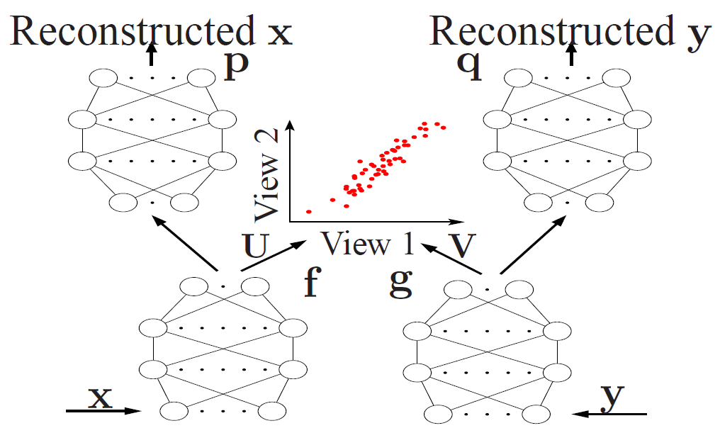

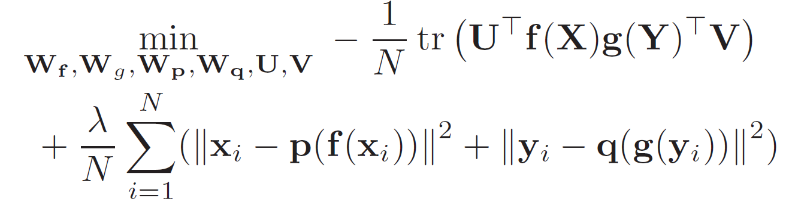

**Experiment:**

Data sets

**References:**